**Date:** 13/11/2016

**Roll No. and Name:** 14BCE154 Chauhan Prasiddh J.

**Course Code and Name:** Open Source Development Lab (CE703)

**Practical No.:** 3 (Wordpress CMS)

**AIM:** To develop a mini project in Wordpress like Youtube

**Description :**

**I developed one project in wordpress like youtube video blog. In this blog there are various features like:**

1. **Channel Creation.**
2. **Playlist Creation**
3. **Category wise Video**
4. **Login / Register**
5. **Video Page**
6. **Like, Share, Embed**

**Output :**

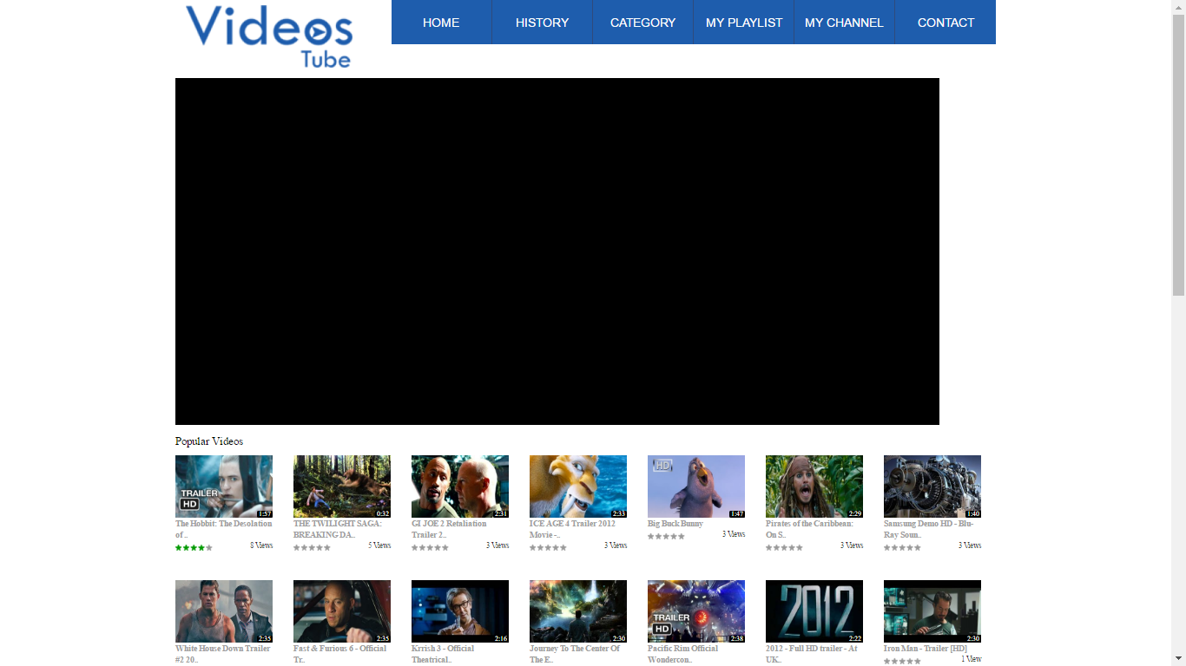

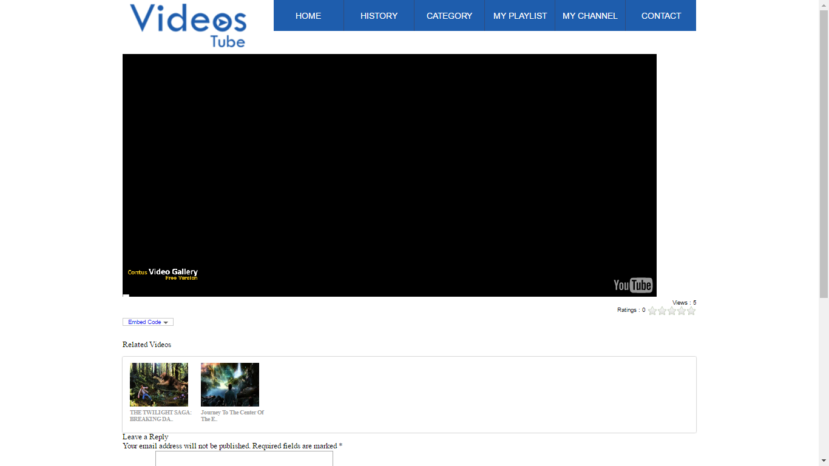

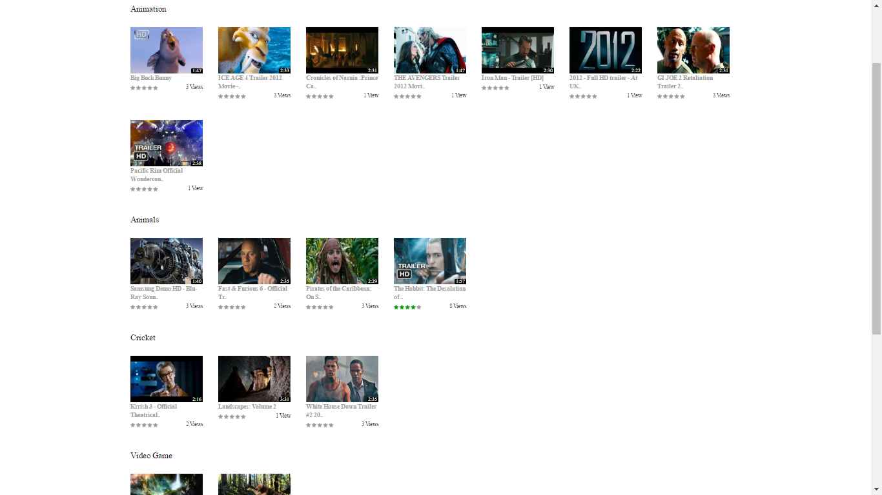

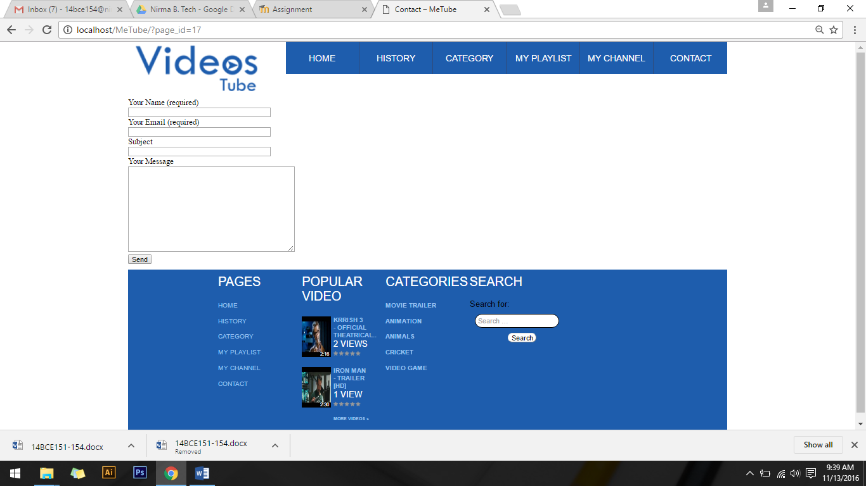

**Conclusions:**

In this project we explored the development of wordpress blog and theme. How to developed own theme in wordpress from html template and how wordpress work. Finally understand the how to work with wordpress.